# PROJECT DESIGN PHASE-I

SOLUTION ARCHITECTURE

|  |  |
| --- | --- |
| DATE | 23 November 2022 |
| TEAM ID | PNT2022TMID17180 |
| PROJECT NAME | Project – Intelligent Vehicle Damage Assessment and Cost Estimator For Insurance Companies |
| MAXIMUM MARKS | 4 Marks |

SOLUTION ARCHITECTURE :

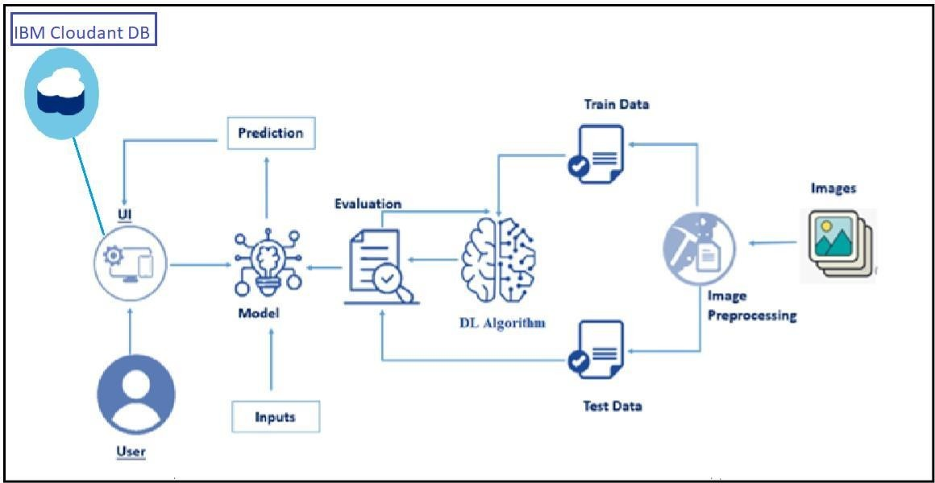

# OUTLINE ARCHITECTURE :

